Name: ________________________________________________ Block: _______

**Unit 7: Quadratic Expressions**

**Learning Goal 7.1 – Operations with Polynomials**

In this unit, you will learn how to do the following:

**Learning Target #1: Operations with Polynomials**

* Classify polynomials by degree and terms
* Add polynomials
* Subtract polynomials
* Multiply polynomials
* Apply operations of polynomials to real world problems

|  |  |  |  |  |
| --- | --- | --- | --- | --- |
| Mon, 1/6  *Day 1:*  Review Expectations, Classify Polynomials | Tues, 1/7  *Day 2:*  Adding & Subtracting Polynomials | Wed, 1/8  *Day 3*:  Multiplying Polynomials | Thurs, 1/9  *Day 4:*  Applications with Polynomials | Fri, 1/10  *Day 5:*  **Learning Goal 7.1 Assessment** |
| Mon, 1/13 | Tues, 1/14 | Wed, 1/15 | Thurs, 1/16 | Fri, 1/17 |
| Mon, 1/20 | Tues, 1/21 |  |  |  |

**Tutoring Times**

|  |  |  |  |  |  |
| --- | --- | --- | --- | --- | --- |
|  | **Monday** | **Tuesday** | **Wednesday** | **Thursday** | **Friday** |
| **AM** | None | Mr. Sims  7:45-8:15  Room 9223 |  | Mr. Sims  7:45-8:15  Room 9223 |  |
| **PM** |  |  |  |  | None |

**Day 1 – Classifying Polynomials**

A **POLYNOMIAL** is a mathematical expression consisting of terms, which can include a constant, variable, or product of a constant and variable, that are connected together using addition or subtraction. Variables must have exponents raised to whole number exponents.

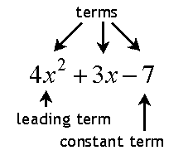

Number of Terms: _________________

Terms: ____________________________

Coefficient(s): ____________________

Constant(s): ______________________

**Cross off all expressions that are NOT polynomials:**

**-8x5 + 2x - 7**

**6x-2 – 3x**

Polynomials CANNOT contain:

* Radicals
* Fractional exponents
$$3x^{4}-\sqrt{x}$$

* Negative exponents
$$\frac{1}{x^{3}}$$

* No variables in the denominator

**-9 + x**

**4x2**

Polynomials are typically written in **STANDARD FORM**, which means the terms are arranged in decreasing order from the largest exponent to the smallest exponent. When you write polynomials in standard form, you can easily identify the degree of the polynomial. The **DEGREE** is the largest exponent of the variable in the polynomial.

**Rewrite each polynomial in standard form. Then identify the degree of the polynomial:**

a. 5x – 6x2 – 4 b. -7x + 8x2 – 2 - 8x2 c. 6(x – 1) – 4(3x2) – x2

Standard Form: Standard Form: Standard Form:

Degree: Degree: Degree:

**Classifying Polynomials**

Polynomials are classified by **DEGREE** and **NUMBER OF TERMS:**

|  |  |  |
| --- | --- | --- |
| **Degree** | **Name** | **Example** |
|  |  |  |
|  |  |  |
|  |  |  |
|  |  |  |

|  |  |  |
| --- | --- | --- |
| **Terms** | **Name** | **Example** |
|  |  |  |
|  |  |  |
|  |  |  |
|  |  |  |

Complete the table below. Simplify the expressions or put in standard form if necessary.

|  |  |  |  |
| --- | --- | --- | --- |
| **Polynomial** | **Degree** | **# of Terms** | **Classification** |
| **8x** |  |  |  |
| **x2 – 4** |  |  |  |
| **10** |  |  |  |
| **-24 + 3x – x2** |  |  |  |
| **5x3 – 12 + 8** |  |  |  |
| **7x – 9x + 1** |  |  |  |
| **4x2 – 5x3 – 4 + 5x -1** |  |  |  |
| **2x + 3 – 7x2 + 4x + 7x2** |  |  |  |

**Day 2 - Adding & Subtracting Polynomials**

When adding, use the following steps to add polynomials:

* Put polynomials in standard form.
* Line up the like terms
* Add
* Make sure final answer is in standard form

a.  b. 

+ +

c. (5 –2x + x2 + 7) + (3x2 + 7 – 4x) d. (2x2 + x – 5) + (x + x2)

**Application**: Find an expression that represents the perimeter of the house.

What does it mean to find the perimeter of an object?

Perimeter of the house:

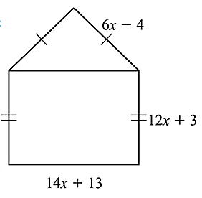

**Subtracting Polynomials**

Subtracting polynomials is similar to adding polynomials except we have to take care of the minus sign first. Subtracting polynomials require the following steps:

* Put each polynomial in standard form and combine like terms if possible.
* Change the subtraction sign to an addition sign and place a negative sign in front of the second polynomial.
* Distribute the minus sign to the second polynomial only - do not change anything with the first polynomial.

*Distributing the minus sign to the second polynomial changes the sign of every term to the opposite of what it originally was.*

* Line up the like terms and add.
* Make sure polynomial is in standard form.

a. (7x2 – 2x + 1) – (-3x2 + 4x – 7) b. (3x2 + 5x) – (4x2 + 7x – 1)

+ +

c. (5x2 – 4x + 8) – (-2 + 3x) d. (3 – 5x + 3x2) – (-x + 2x2 - 4)

e. (8x + x2 – 6) – (-10x + 7 – 2x2) f. (-7x2 + 8x – 4) – (2 – 14x2)

**Day 3 – Multiplying Polynomials**

There are several different ways to multiply polynomials. You will learn the distributive method and area method. Once you have practiced both methods, you can determine which one you like best and works for you.

EXAMPLE 1:

**Distributive Method:** 2x(x – 4) **Area Method:** 2x(x – 4)

|  |  |
| --- | --- |
|  |  |

EXAMPLE 2:

**Distributive Method:** (x + 2)(x – 9) **Area Method:** (x + 2)(x – 9)

|  |  |
| --- | --- |
|  |  |
|  |  |

EXAMPLE 3:

**Distributive Method:** (2x - 4)2 **Area Method:** (2x – 4)2

|  |  |
| --- | --- |
|  |  |
|  |  |

EXAMPLE 4:

**Distributive Method:** (x + 6)(x - 6) **Area Method:** (x + 6)(x – 6)

|  |  |
| --- | --- |
|  |  |
|  |  |

**Practice Problems**

Simplify these problems with a method of your choosing.

1. (x – 7)(x + 4) 2. (x – 9)2

3. (x + 10)(x – 10) 4. x(x - 12)

5) (3x +7)(2x +1) 6. (x + 3)2

7. (2x – 1)(3x – 4) 8. (4x – 5)(x2 + 3x – 6)

**Day 4: Applications Using Polynomials**

a. Write an expression that represents the perimeter and area of this rectangle.

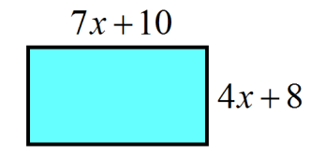

b. The measures of two sides of a triangle are given. If *P* is the perimeter, and , find the measure of the third side.

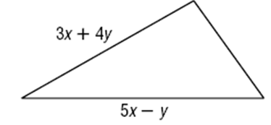

c. Write an expression that represents the volume of this rectangular prism. (V = *lwh*)

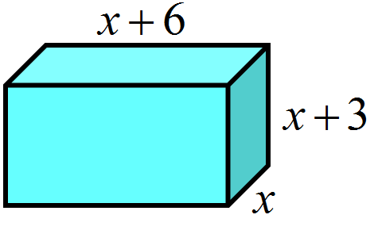

d. You are designing a rectangular flower bed that you will border using brick pavers. The width of the board around the bed will be the same on every side, as shown.

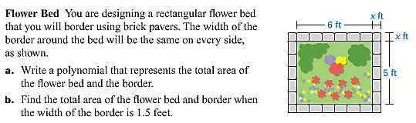a. Write a polynomial that represents the total area of the flower bed and border.

b. Find the total area of the flower bed and border when the width of the border is 1.5 feet.

e. Find the expression that represents the area not covered by the mailing label.

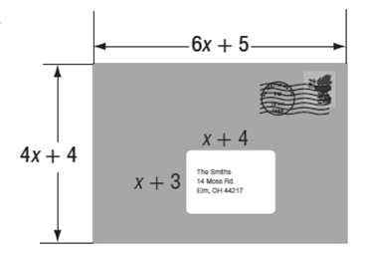

f. The polynomial  models the cost a company incurs from making an item at a price *x*. The polynomial  represents the income from selling the same item at a price x. Write a polynomial that expresses the profit from making and selling the item. (hint: profit = income – cost)