**Day 7-Graphing Lines Name: ______________________**

**Practice Assignment Date: ____________ Block: _____**

**Directions:** Solve for y (if necessary). Name the slope and y-intercept. Graph the following lines.

1. y = -5 2. x = 5 3. x = -4

Slope: _______ Y-int: _______ Slope: _______ Y-int: _______ Slope: _______ Y-int: _______

4. y = 2 5. y = -6x + 3 6. y = ¼x + 2

Slope: _______ Y-int: _______ Slope: _______ Y-int: _______ Slope: _______ Y-int: _______

7. y =- x + 3 8. y = 2x + 5 9. x + y = -1

Slope: _______ Y-int: _______ Slope: _______ Y-int: _______ Slope: _______ Y-int: _______

**Directions:** Name the equation of the line.

10. m = ________ b = ________ 11. m = ________ b = ________ 12. m = ________ b = ________

Eqtn: _______________________ Eqtn: _______________________ Eqtn: _______________________

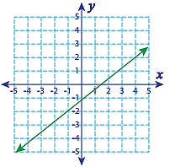 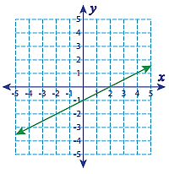 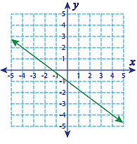

13. m = ________ b = ________ 14. m = ________ b = ________ 15. m = ________ b = ________

Eqtn: _______________________ Eqtn: _______________________ Eqtn: _______________________

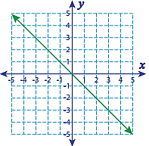 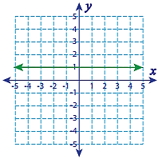 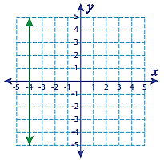

16. m = ________ b = ________ 17. m = ________ b = ________ 18. m = ________ b = ________

Eqtn: _______________________ Eqtn: _______________________ Eqtn: _______________________

